Meeting Document: 14 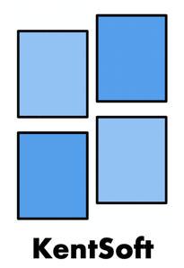

Name of company: KentSoft

Meeting location: Templeman Library – Group study room 2

Meeting date: 28/02/20

Attendance: Adil, Rahul, Samuel and Tsotne

Extra info: N/A

**Agenda:**

* Populate Trello board with all tasks
* Read over feedback
* Create UML class diagram for Personal Details
* Begin coding for Personal Details by using the UML class diagram

**Discussion points:**

* Trello tasks were added
* We started to brainstorm different ways on how to implement feedback given for stage 3
* Discussed whether we should implement a new GANTT chart style based off the feedback of having odd scaling
* Discussed how authentication level/role should be selected in the login and logout operations
* Ensure Java doc is completed going forward

|  |  |  |  |  |
| --- | --- | --- | --- | --- |
| **Tasks to be completed** | **Who** | **Date Set** | **Due** | **Completed** |
| Create Trello board | SL, RP, TG, AAJ | 25/02/20 | 25/02/20 | Y |
| Fill out weekly document | SL, RP, TG, AAJ | 25/02/20 | 25/02/20 | Y |
| Create stage 4 folder on GitLab | SL, RP, TG, AAJ | 25/02/20 | 25/02/20 | Y – created but not yet pushed |
| Read brief | SL, RP, TG, AAJ | 25/02/20 | 25/02/20 | Y |
| **Populate Trello board** | **TG, AAJ, SL, RP** | **28/02/20** | **29/02/20** | **N** |
| **Create/Update UML diagram** | **RP, SL** | **28/02/20** | **29/02/20** | **N** |
| **Review GANTT chart scaling from feedback** | **AAJ** | **28/02/20** | **28/02/20** | **Y** |